2015 - 16



Python

Computer PRACTICALS

Mohit Manoj

INDEX

1 To print no’s from 1 to 10 using “While” loop 3

2 To find the sum 3

3 Finite Loop 3

4 Infinite Loop 4

5 To identify type of integer 4

6 To check if given is a palindrome. 4

7 To check if given numbers form a triangle 5

8 To find the last term of an arithmetic progression. 6

9 To print the Armstrong numbers in a given range. 6

10 To find the area and circumference of a circle. 6

11 To find the sum of even numbers in a given range. 7

12 To print even numbers up till ‘n’ 7

13 To square a number without the use of import math or “**” 7

14 To find the distance using distance formula. 8

15 To print ‘n’ terms of the Fibonacci series 8

16 To find the factors of a given number 8

17 To calculate gross salary 9

18 To check if the given year is a leap year 9

19 To print sum of digits and reverse of Input 10

20 To check if the given number is odd or even 10

21 To check if the given number is prime or composite 10

22 To print all the prime numbers in a given range 11

23 To check if you are eligible to vote in India 11

24 To find the volume of a frustum of a cone of given dimensions 11

25 To find the nature and values of the roots of a quadratic equation 12

26 To create a simple calculator 13

# 

# To print no’s from 1 to 10 using “While” loop

## Code

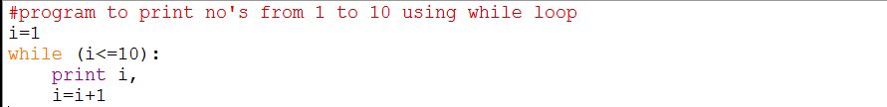

## Output



# To find the sum

## Code

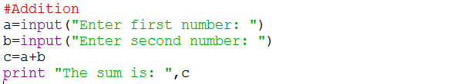

## Output

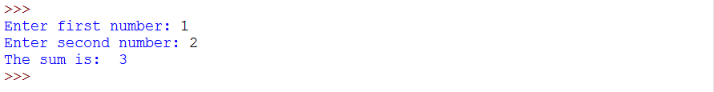

# Finite Loop

## Code

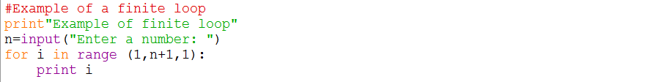

## Output

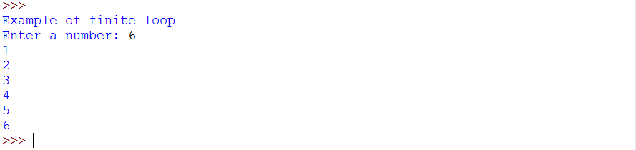

# 

# Infinite Loop

## Code

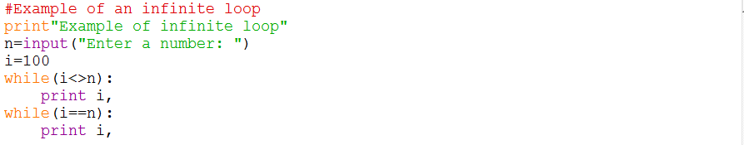

## Output

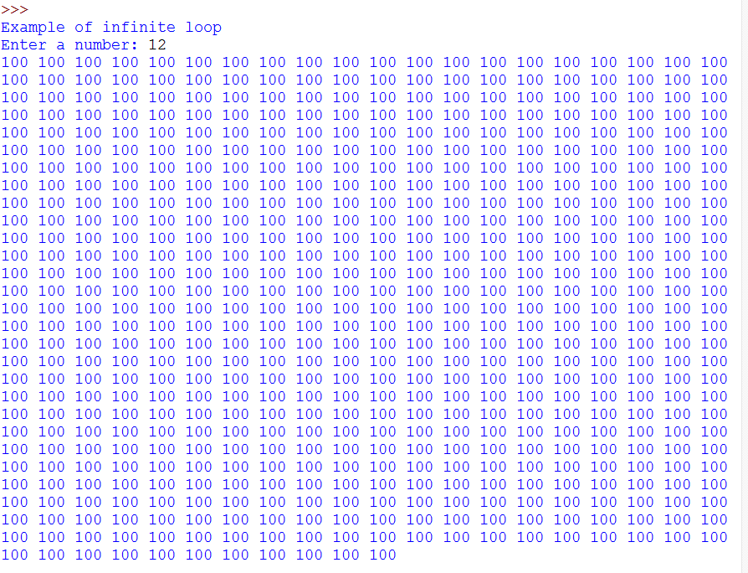

# To identify type of integer

## Code

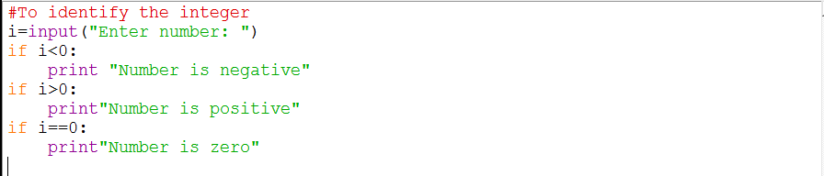

## Output

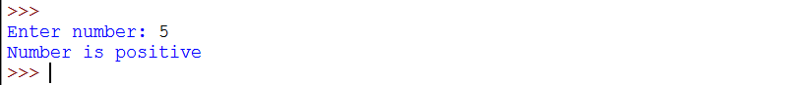

# To check if given is a palindrome.

## Code

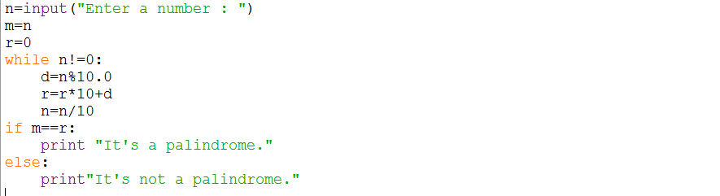

## 

## Output



# To check if given numbers form a triangle

## Code

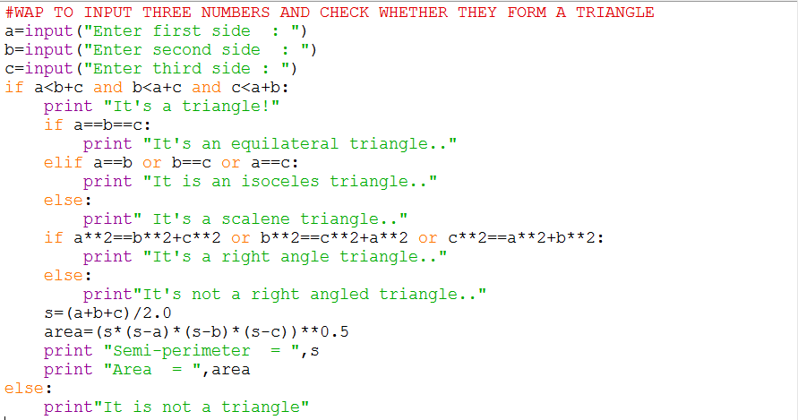

## 

## Output

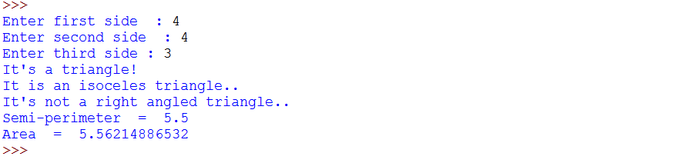

# 

# To find the last term of an arithmetic progression.

## Code

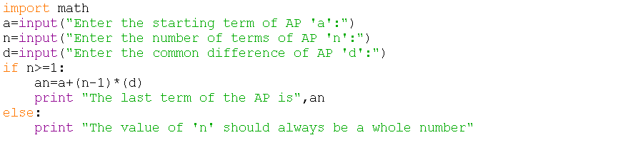

## Output

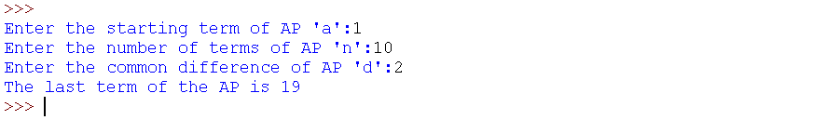

# To print the Armstrong numbers in a given range.

## Code

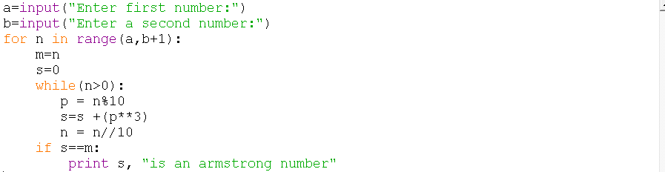

## Output

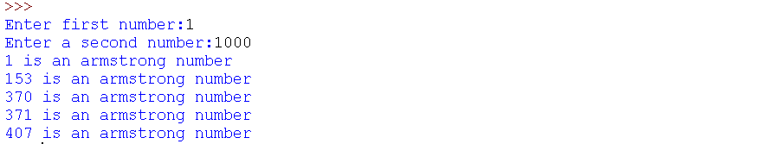

# To find the area and circumference of a circle.

## Code

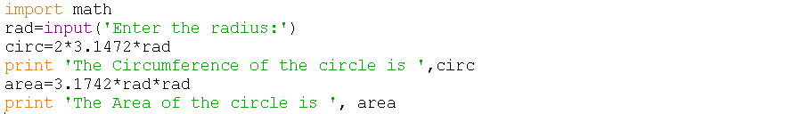

## 

## Output



# To find the sum of even numbers in a given range.

## Code

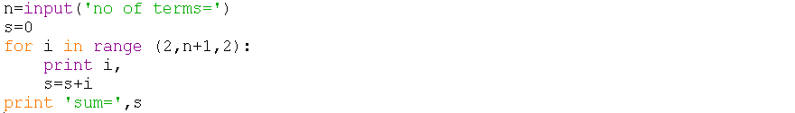

## Output



# To print even numbers up till ‘n’

## Code

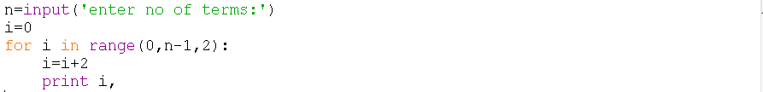

## Output



# To square a number without the use of import math or “**”

## Code

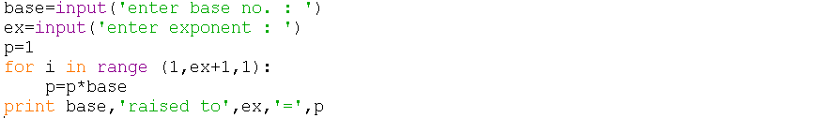

## Output

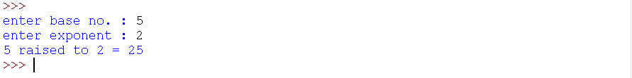

# 

# To find the distance using distance formula.

## Code

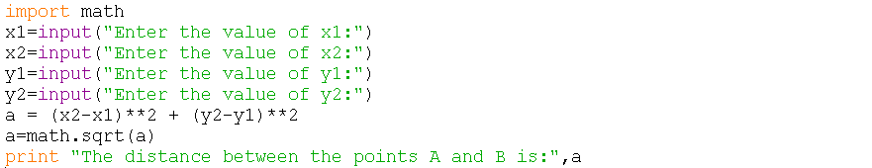

## Output

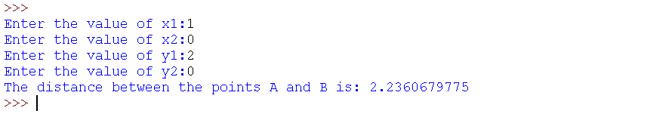

# To print ‘n’ terms of the Fibonacci series

## Code

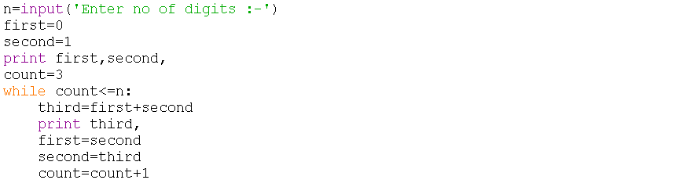

## Output

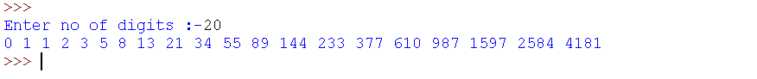

# To find the factors of a given number

## Code



## Output



# 

# To calculate gross salary

## Code

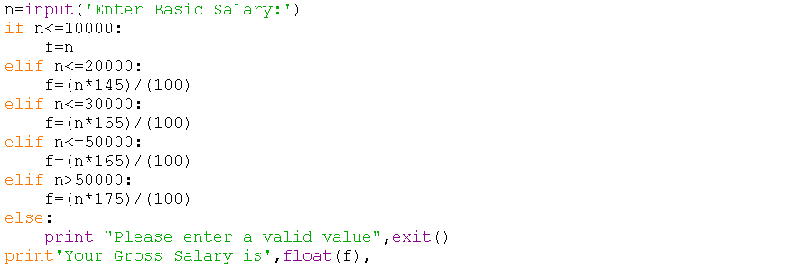

## Output

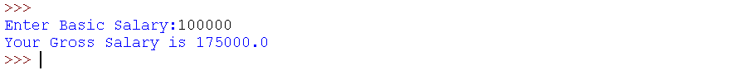

# To check if the given year is a leap year

## Code

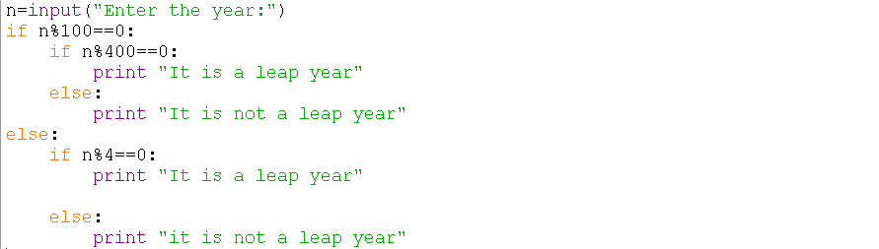

## Output

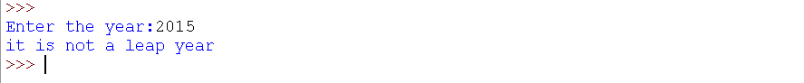

# 

# To print sum of digits and reverse of Input

## Code

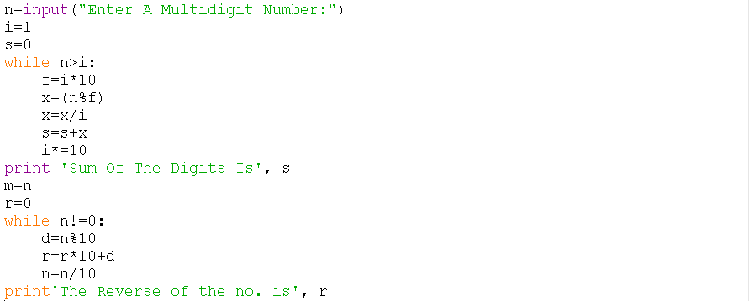

## Output

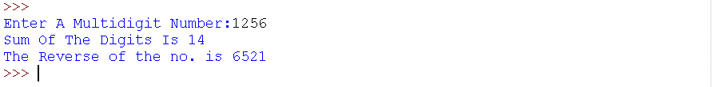

# To check if the given number is odd or even

## Code

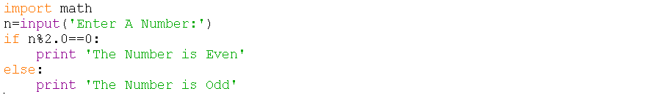

## Output



# 

# To check if the given number is prime or composite

## Code

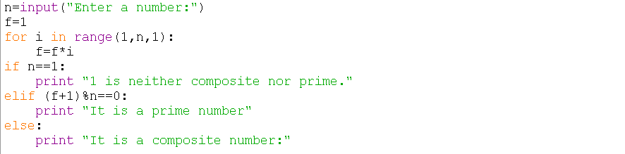

## Output



# To print all the prime numbers in a given range

## Code

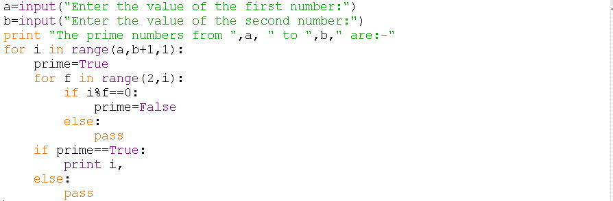

## Output

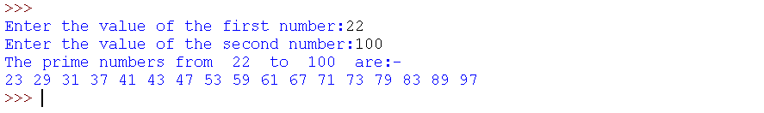

# To check if you are eligible to vote in India

## Code

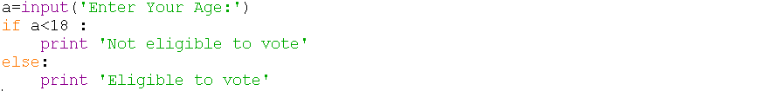

## Output

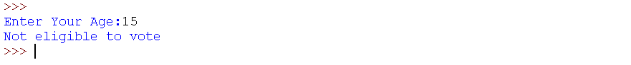

# To find the volume of a frustum of a cone of given dimensions

## Code

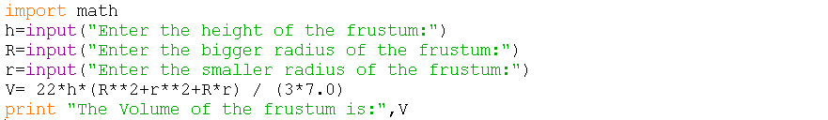

## Output

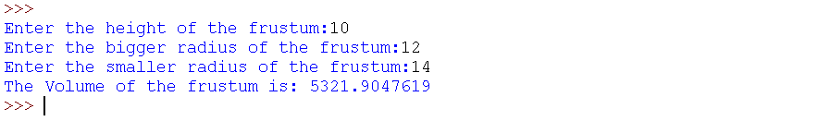

# To find the nature and values of the roots of a quadratic equation

## Code

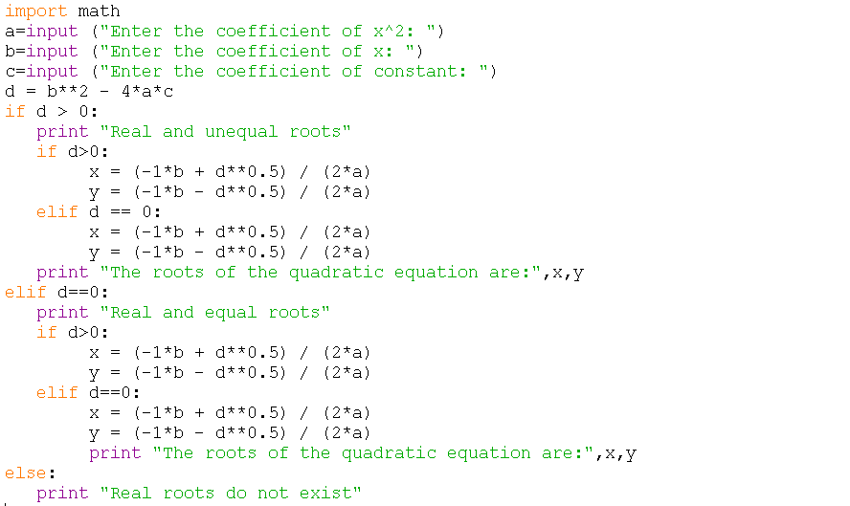

## Output

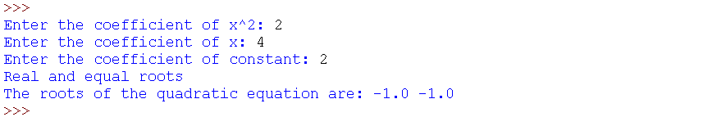

# 

# To create a simple calculator

## Code

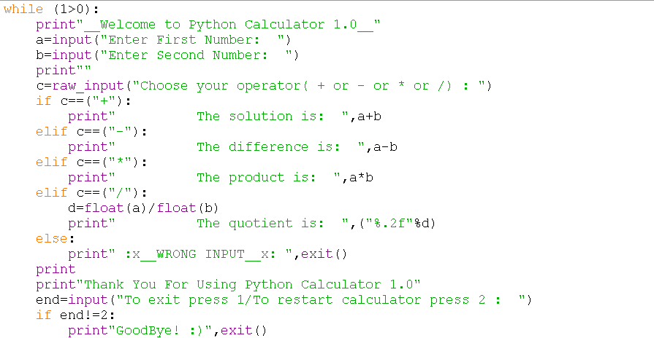

## Output

